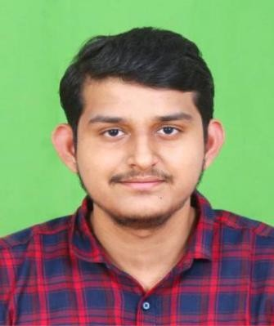**Name:Gokula Krishnan S**[**Email:gokulakrishnans06754@gmail.com**](mailto:gokulakrishnans06754@gmail.com) **Mobile:+91-7397142280**

**Linkedin:** <https://bit.ly/37KJjlT>

**Github:** [Gokula-Krishnan9991 (github.com)](https://github.com/Gokula-Krishnan9991)

# CAREER OBJECTIVE



Looking for the challenging role to utilize my technical skills for the growth of the organization as well as to enhance my knowledge to learn new technologies in the IT sector

# EDUCATIONAL QUALIFICATIONS



|  |  |  |  |
| --- | --- | --- | --- |
| **Course** | **Institution/University** | **Year of** | **Performance** |
| **(Stream)/Examination** | **Passing** |
| B.Tech | SASTRA Deemed University | 2021 | 63% |
| HSC | P.R.G Higher Secondary | 2017 | 96.08% |
| School |
| SSC | St.peters Matriculation School | 2015 | 97.2% |

**PROJECTS UNDERTAKEN**

**Miniproject Title**: Brain tumor detetction using Image processing

**Contribution**: Done a coding part using Matlab

**Overview:** For the given input image ,we need to extract the tumor by using edge detection algorithm

# KEY SKILLS



Java : Medium level proficiency

C : Basic level proficiency

Datastructures and Algorithms : Basic level proficiency

**Online Completed**

[Datastructures and algorithms deep dive using java](https://www.udemy.com/certificate/UC-070a666a-13fd-40ec-b138-8d0bdbf7aa31/)

## PERSONAL INFORMATION



**Date of Birth Address Languages**

## : 02.09.1999

**: 116, south car street, palani-624601**

**: Tamil -Native proficiency**

**English-Limited working proficiency**

## Telugu-basic level proficiency